EXPERIMENT NO – 9

AIM:
Uniform Quantization and Finite Word-Length Effects in Digital Signal Processing Using MATLAB

PROGRAM:
Clc; clear; close all;

%% PARAMETERS
A=1; f=50; Fs=1000; N=1000;
N=0:N-1; x=A*sin(2*pi*f*n/Fs);
B=8; bits=[4 8 12 16];

%% 8-BIT QUANTIZATION
D=2*A/2^B;

Xr=D*round(x/D); % Rounding
Xt=D*fix(x/D); % Truncation

Er=x-xr; % Rounding error
Et=x-xt; % Truncation error

SQr=10*log10(mean(x.^2)/mean(er.^2));
SQt=10*log10(mean(x.^2)/mean(et.^2));

%% INPUT / OUTPUT QUANTIZATION
Xq=xr;
Y=x;
Yq=D*round(y/D);
Eo=y-yq;
SQout=10*log10(mean(y.^2)/mean(eo.^2));

%% WORD-LENGTH COMPARISON
For k=1:length(bits)
B=bits(k);
D=2*A/2^b;
Qr=d*round(x/d);
Qt=d*fix(x/d);
Er1=x-qr; et1=x-qt;

Step(k)=d;
sqnrR(k)=10*log10(mean(x.^2)/mean(er1.^2));
sqnrT(k)=10*log10(mean(x.^2)/mean(et1.^2));
maxER(k)=max(abs(er1));
maxET(k)=max(abs(et1));
end

%% RESULTS
Fprintf(‘\n========== QUANTIZATION RESULTS ==========\n’);
Fprintf(‘Amplitude = %.1f | Frequency = %d Hz | Fs = %d Hz\n’,A,f,Fs);
Fprintf(‘Samples = %d | Main word length = %d bits\n’,N,B);
Fprintf(‘8-bit Step Size = %.7f\n’,D);
Fprintf(‘Rounding SQNR = %.4f dB\n’,SQr);
Fprintf(‘Truncation SQNR = %.4f dB\n’,SQt);
Fprintf(‘Output SQNR = %.4f dB\n’,SQout);
Fprintf(‘Max Rounding Error = %.6f\n’,max(abs(er)));
Fprintf(‘Max Truncation Error = %.6f\n’,max(abs(et)));

%% FIRST 10 SAMPLES
T1=table(n(1:10)’,x(1:10)’,xr(1:10)’,er(1:10)’,xt(1:10)’,et(1:10)’,…
‘VariableNames’,{‘n’,’Original’,’Rounded’,’RoundError’,’Truncated’,’TruncError’});
Disp(T1);

%% WORD-LENGTH TABLE
T2=table(bits’,step’,sqnrR’,sqnrT’,maxER’,maxET’,…
‘VariableNames’,{‘Bits’,’StepSize’,’SQNR_Round_dB’,…
‘SQNR_Trunc_dB’,’MaxError_Round’,’MaxError_Trunc’});
Disp(T2);

%% OUTPUT PARAMETER TABLE
Parameter={
‘Quantized signal’
‘Quantization error’
‘SQNR’
‘Word-length comparison’};

Observation={
Sprintf(‘8-bit rounding, Delta = %.7f’,D)
Sprintf(‘Max rounding error = %.6f’,max(abs(er)))
Sprintf(‘Rounding = %.4f dB; Truncation = %.4f dB’,SQr,SQt)
‘SQNR increases as word length increases’};

Unit={
‘Amplitude’
‘Amplitude’
‘dB’
‘Bits / dB’};

Disp(table(Parameter,Observation,Unit));

%% GRAPHS
Figure;
Plot(n(1:100),x(1:100)); hold on;
Stairs(n(1:100),xr(1:100));
Grid on; xlabel(‘Sample n’); ylabel(‘Amplitude’);
Title(‘Original and 8-bit Quantized Signal’);
Legend(‘Original’,’Quantized’);

Figure;
Plot(n,er); hold on; plot(n,et);
Grid on; xlabel(‘Sample n’); ylabel(‘Error’);
Title(‘Rounding and Truncation Quantization Error’);
Legend(‘Rounding’,’Truncation’);

Figure;
Plot(bits,sqnrR,’o-‘); hold on;
Plot(bits,sqnrT,’s—‘);
Grid on; xlabel(‘Word Length (bits)’); ylabel(‘SQNR (dB)’);
Title(‘SQNR vs Word Length’);
Legend(‘Rounding’,’Truncation’);

Figure;
Semilogy(bits,maxER,’o-‘); hold on;
Semilogy(bits,maxET,’s—‘);
Grid on; xlabel(‘Word Length (bits)’);
Ylabel(‘Maximum Quantization Error’);
Title(‘Quantization Error vs Word Length’);
Legend(‘Rounding’,’Truncation’);

%% FINAL RESULT
Fprintf(‘\n========== FINAL RESULT ==========\n’);
Fprintf(‘Uniform quantization using rounding and truncation was performed.\n’);
Fprintf(‘Quantization error and SQNR were calculated.\n’);
Fprintf(‘Increasing word length reduces quantization error and improves SQNR.\n’);
Fprintf(‘Finite word-length effects are therefore verified.\n’);

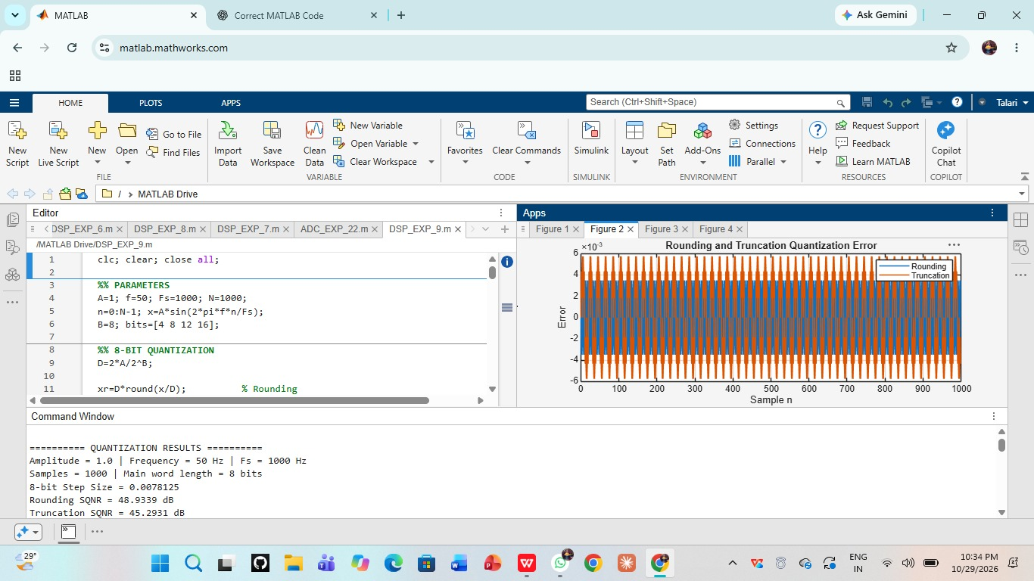
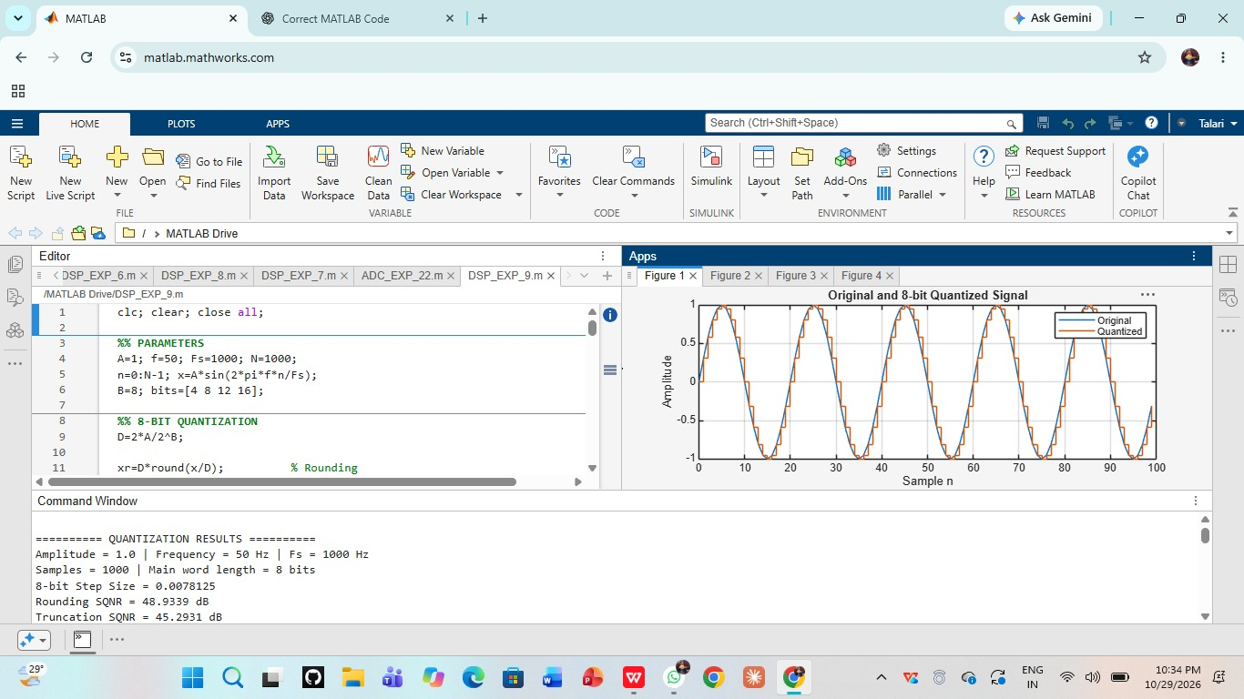
OUTPUT:





